System 1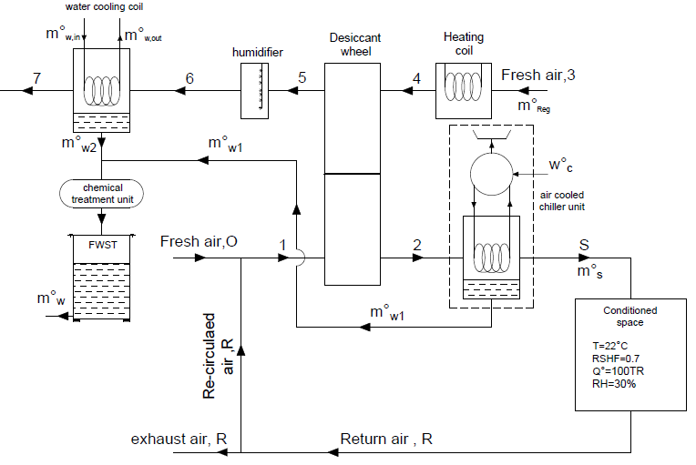

System 2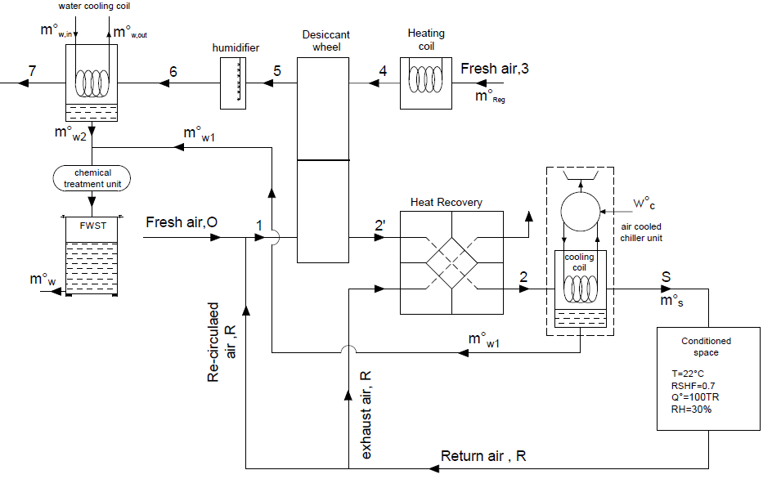

System 3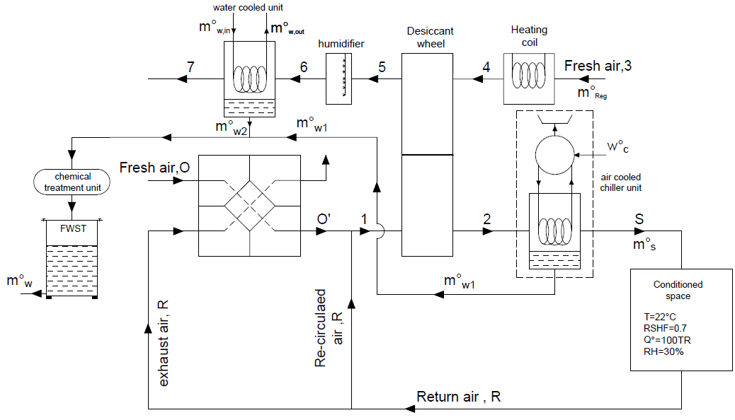

Fig. 1Schematic diagram of the proposed systems



System 1



System 2



System 3

Fig. 2 Psychrometric chart of systems 1, 2 and 3

|  |
| --- |
| **(a)** |
| **(b)** |
| **(c)** |
| **(d)** |

Fig. 3: Effect of outdoor air ratio on (a) m◦w, (b) Q◦cc, (c) E◦, and (d)% power saving

(d)

(c)

(b)

(a)

(c)

(d)

(b)

|  |
| --- |
| **(a)** |
| **(b)** |
| **(c)** |
| **(d)** |

Fig. 4 Effect of ambient air temperature(a) m◦w, (b) Q◦cc, (c) E◦, and (d)% power saving

|  |
| --- |
| **(a)** |
| **(b)** |
| **(c)** |
| **(d)** |

Fig. 5: Effect of ambient specific humidity on (a) m◦w, (b) Q◦cc, (c) E◦, and (d)% power saving

|  |
| --- |
| **(a)**  **(b)**  **(c)** |
|  |
|  |

Fig. 6: Effect of the operating parameters on the total cost savings of   
systems-2 and system-3